Project Scope for milestone #1

Overview:

Fitivity is a location-based application that helps people discover, organize and participate in group physical activities like pick-up sports, group exercise and other recreational activities.

With fitivity, users join groups based on their specific activity interest and location. Example: Basketball at the YMCA Boston. Being part of a group allows users to be able to receive push notifications whenever an activity is created. Fitivity allows people to be able to organize that pick-up basketball game down the street or find a running group to help you stay motivated.

User Experience:

1) Loading Screen – When a user launches the fitivity application, this screen will appear while the application loads.



2) Sign-in or Sign-up – For a first time user, they are brought to this screen. This gives a user the option to a) sign-in to an account that they had previously created b) create a new account c) sign-up with their Facebook account

The “sign in” button would be omitted from this frame because a user already signs in using the text boxes labeled “username” and “password.”

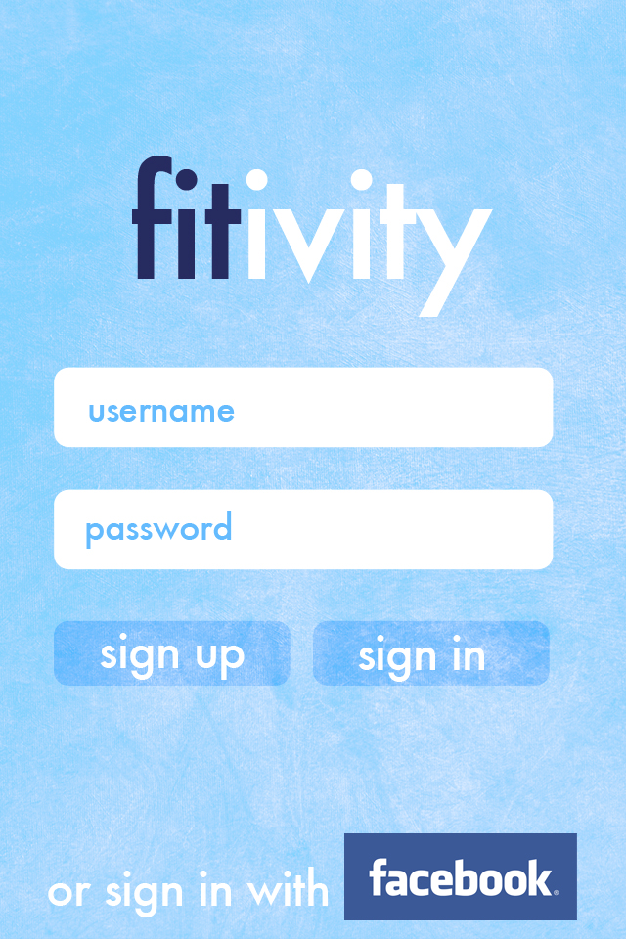

3) Sign-Up Screen – if a user chooses “sign-up” this will be the page they will be brought to. The bottom buttons labeled “sign up” and “sign in” would be omitted, and replaced with a button that says “done.”

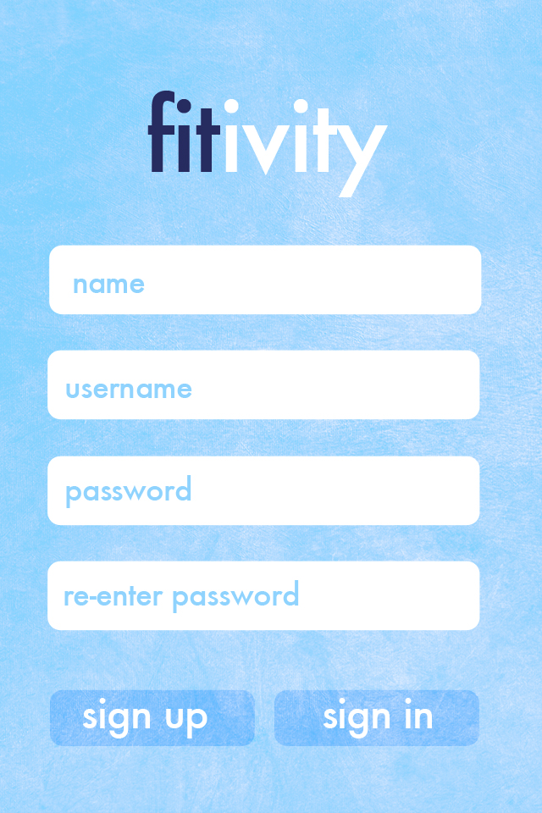

4) Discover Tag – A user will come to this screen once they have signed up for the service. If a user is already signed up or has an existing account, they will always come to this screen first once the app has loaded.

The discover tag is similar to a news feed. Users will use this tag to find out what activities are going on around them. Specifically, users can find the following in the discover feed; what individuals started a group, how many people are in a group, if their was an activity proposed in a group, if their was a comment on a proposed activity. The following examples correspond with the buttons in the wireframes and are in order from top to bottom.

1. This first button shows what a certain user is doing: the example below shows “Jack is playing” -- however, to make all the language generic, it should say “Jack is doing”. This button was created assuming that Jack started the group basketball at YMCA. This also assumes that Jack started the group and no one else has joined it yet. Once people start joining the group, the number gets tallied up and the button looks like example number two. Also, if a user clicks this button, they will be brought to the group page for Basketball at YMCA. In the corner of this button, you can see that it says how far a user is from this group – in this example it is .4 miles. Lastly, you can see what time the comment was made, as shown the comment was made at 4:01pm. If a user clicks on the profile picture, they will be brought to that specific users profile. In this example, they will be brought to Jack’s profile.
2. The next button is what happens when people join a group that was previously started by an individual user. If a user clicks on this button they will be brought to the group screen.
3. This is a button that shows that a user in the Softball at Bowditch field group has proposed a group activity. By clicking on this button, a user will be brought to the proposed activity page, were they will be able to view the information related to the activity proposed.
4. This is a button that shows that users have commented on an activity that was proposed. If a user clicks on this button, they will be brought to the proposed activity page.

Additional Notes on Discover Tag:

1. The feed is ordered by recency. Most recent events are posted at the top and least recent buttons are posted at the bottom. Users can scroll through all the buttons.
2. If you look in the top right, you will see a box that says “today” – for each day, there will be a date.
3. The language needs to be generic. This is why we replaced “Playing” with “doing”.
4. If a user clicks on any of the profile pictures, they will be brought to that users profile.

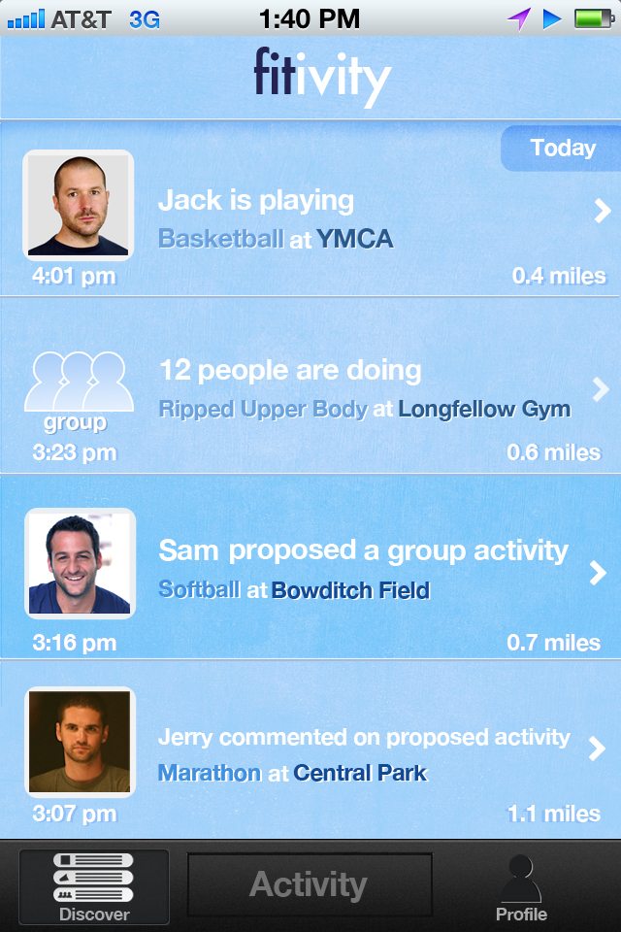

5, 6, 7) The next three screens correspond with the “activity” tag. This tag is used to help a user start a group. Groups are organized based on a users Location and Activity. For example – users doing basketball at the YMCA Boston or users doing Weight Loss at the Cory Gym.

1. This is the “activity” tag. This is the middle screen below that has the two buttons labeled “choose activity” and “choose location” – if a user clicks “choose activity” they will be brought to screen 6 and if a user clicks “choose location” they will be brought to screen 7. Once they choose either a location or an activity, the information gets filled into the box. Example – “choose activity” gets replaced with “Basketball”. Once a user has completed both selections, they automatically are brought to that group page.
2. If a user clicks on “choose activity” they will be brought to this screen. This is the screen that is on the far right. Users can click on a category to open up sub categories, and eventually choose a sub category. For example – users choose “Sports”, then they choose, basketball. The + will turn into a x – used to open or collapse the categories.
3. If a users clicks the “choose location” screen, this is where they will go. This is the bottom screen below the three frames. The first button labeled “without a location” is to be omitted. From this screen users can search through the location or choose a location by scrolling. Also, users can click on the “map” button to get a map view. A user must select a location to create a group. Note: we are using Google places to populate our list of locations.

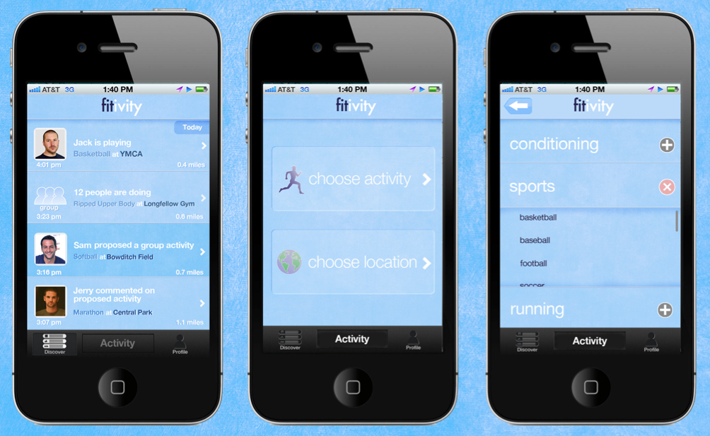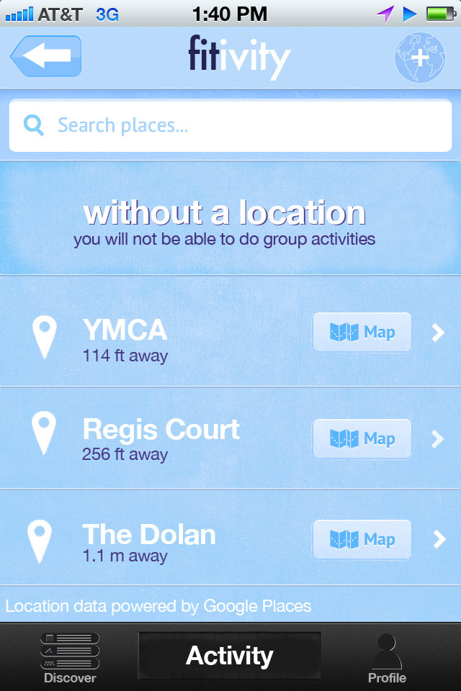

8) Profile Screen – this screen shows a users picture, username, and all the groups they belong to. A users profile photo can either be uploaded or pulled from their Facebook information. Each group is a button that if clicked on will be brought to the group page. Groups can easily be deleted by clicking on the “delete” button in the corner of each group. If you notice, there is an exclamation mark in the top right of the group button. This shows that an activity was proposed in that group. Once a user clicks on this group, the exclamation icon goes away. The icon is suppose to represent that some type of new activity is happening in that group.

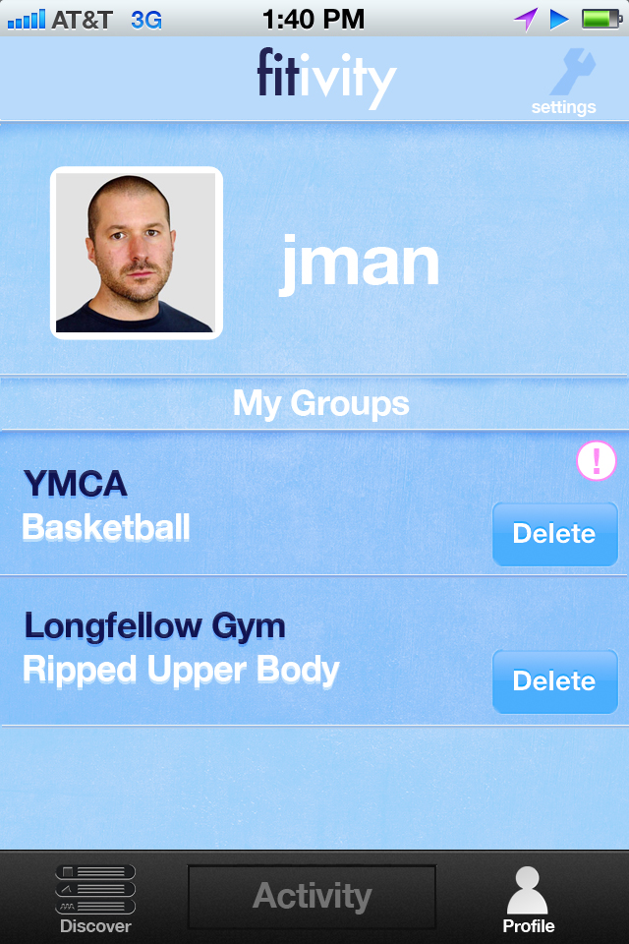

9) This is the “group page” -

Note: There are two types of group pages – 1) With a challenge 2) without a challenge. The example below shows it with a challenge. If there is no challenge, the challenge icon is omitted (star icon). The challenge functionality is part of milestone #2 – so you do not need to worry about this for the first milestone.

Using the group page a user will be able to do a variety of functions:

1. Join Group: this button is shown in the top and is labeled “Join”. – by joining a group, a user is adding them to the group list and it is also placed within their profile. This will also allow users to receive push notifications.
2. Members: this button is shown in the top right. By clicking this, users will be able to see what members are part of this group.
3. Map: this button is shown in the top right – this button brings users to google maps so they can get directions to the location.
4. Propose Activity: this button is next to the “join” button – users will use this button to propose activities. Once they have done this, activities will be displayed in the “discover” feed and in a feed within the group.
5. A specific Proposed Activity – the buttons below proposed activity and join are past activities that have been proposed. If a user clicks on any of these activities, they will be brought to the specific activity screen were they can view the comments people have proposed. If you look in the top right of each button, you can see how long ago the activity was proposed – the example shows “27 minutes ago.” Also, you will see a green ! icon. This icon represents that a comment or many comments have been made in that specific individual activity. This icon never goes away.

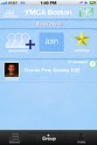

10)

View Members Screen: this screen has a list of each member within a specific group. By clicking on the picture of any member, they can view their profile.

Note: When a user looks at another users profile, they will be able to also view any of their groups. In other words, by accessing a users profile, they can access their groups if desired.

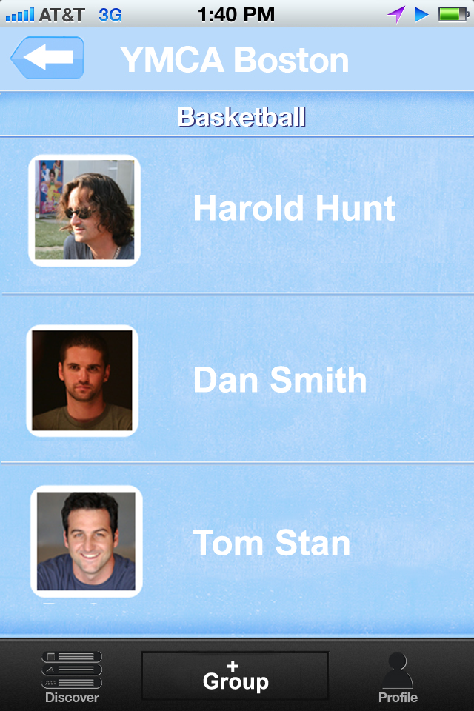

11) Propose Activity Screen and Comment Screen – This is what the screen looks like if a user proposes an activity or if a user comments on a proposed activity. Users will have a 350 character limit. The amount of characters used are shown in the top right corner.

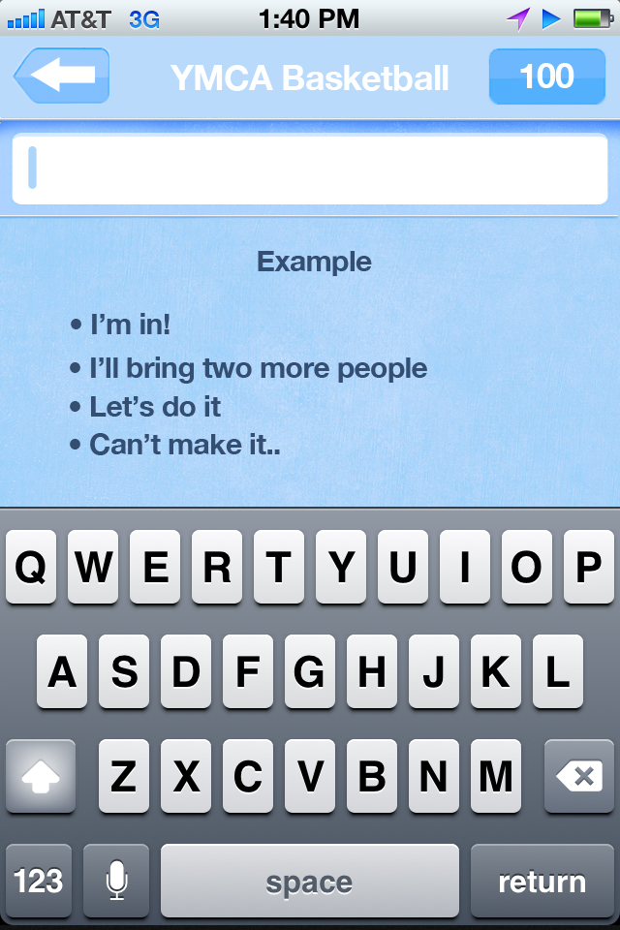

12) This is the specific proposed activity screen. As you can see, users have put comments below regarding the proposed activity. If a user clicks into the comment box, they will be able to write text.

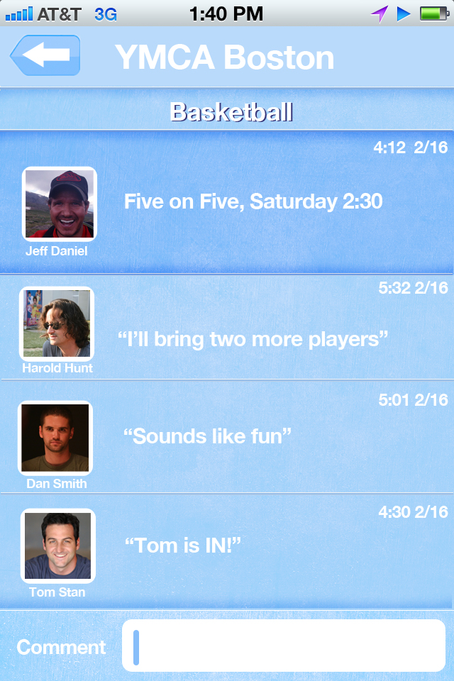

13) Settings: user access settings in the top right of their profile screen. Using the settings, users can do the following:

a) Turn on and off push notifications

b) upload or change their picture

c) change their email

d) change their password

e) change their username

f) sign out

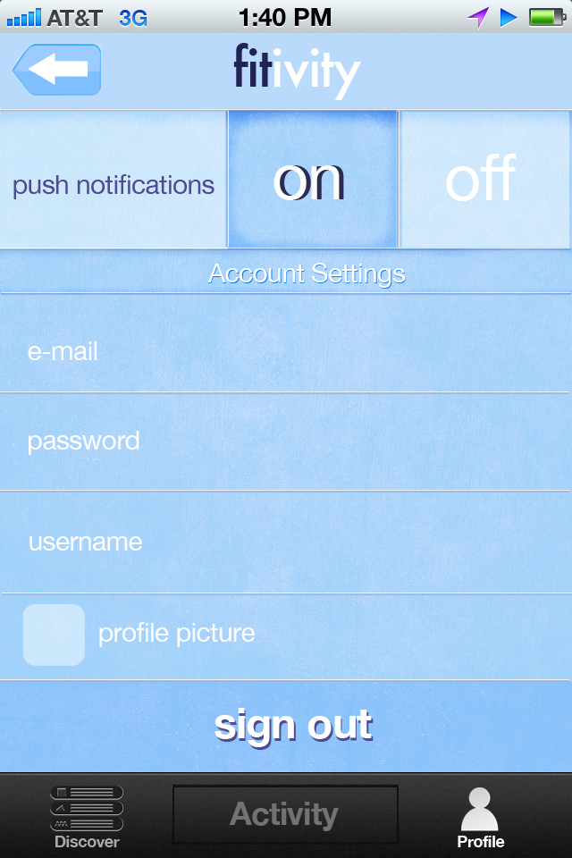

Additional Notes:

Push Notifications: Users receive push notifications for each group that is in their profile. If a user receives a notification, they will have two options – “I’m in” or “Not today”. If they select either one, it gets automatically gets put into the feed. From here, users go straight to the proposed activity screen, and can see that their choice is now listed and if they choose to, they can write additional comments.

Activity Tag: After users select their second option (either activity or location) they will be directly brought to the group page.

Challenges: Like I talked about in the Group Page, challenges will be a separate functionality that will be done in milestone #2.

Add a location: Also, in milestone #2, we will add functionality for a user to add a location.